**BAI652 PeopleTools Assignment 1**

**1. Plan the application**

Project: NAIT###_INSTR

*MENU > BAIST > NAIT###*

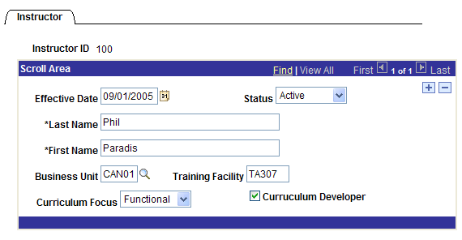

**2. Define Fields**

NAIT###_INSTR_ID

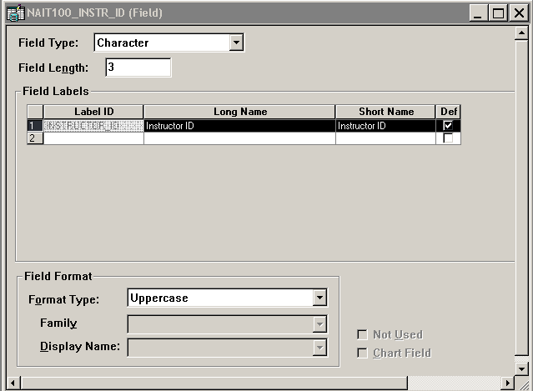

NAIT###_CURRIC_ID

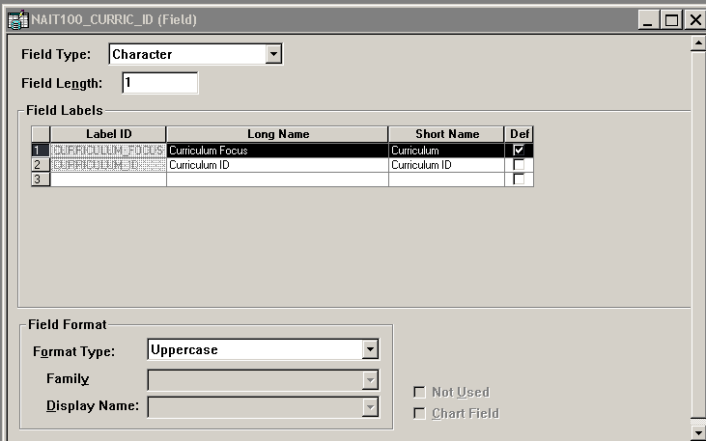

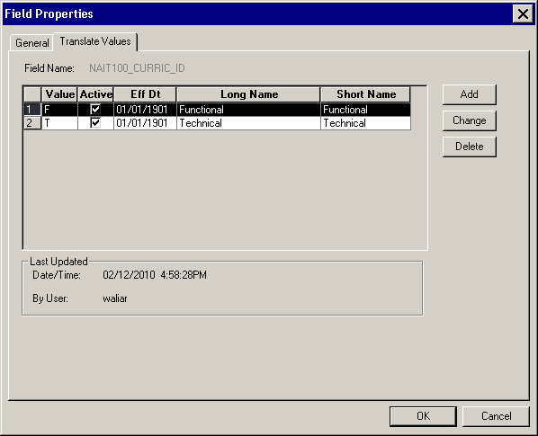

NAIT###_CURRIC_DEV

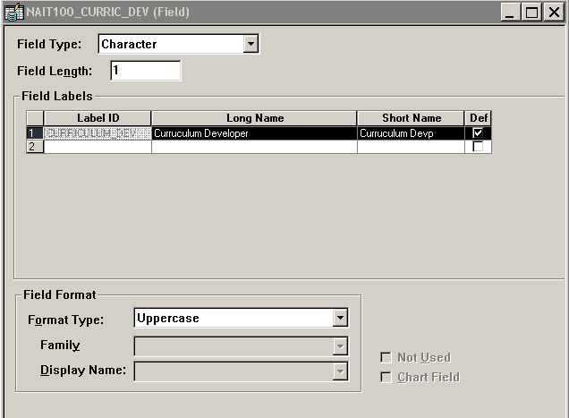

**3. Define Records**

NAIT###_INSTR (use your NAIT### Fields)

Field Display

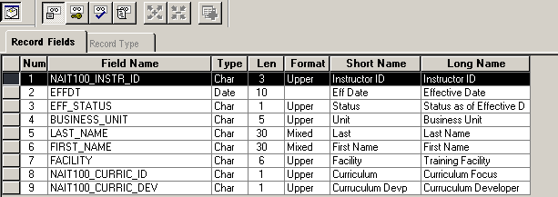

Use Display

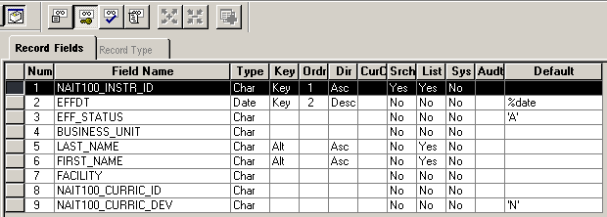

Edit Display

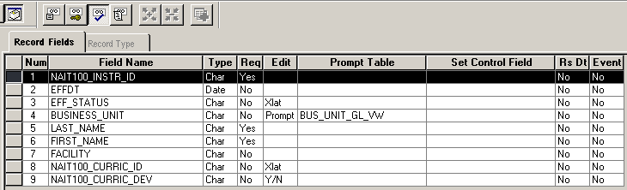

**4. Build Table**

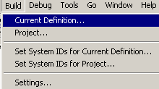

**5. Define Pages**

NAIT###_INSTR

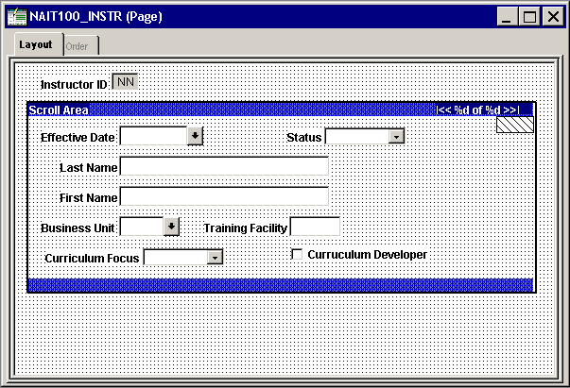

**6. Define Components**

NAIT###_INSTR (use your NAIT###_ Page)

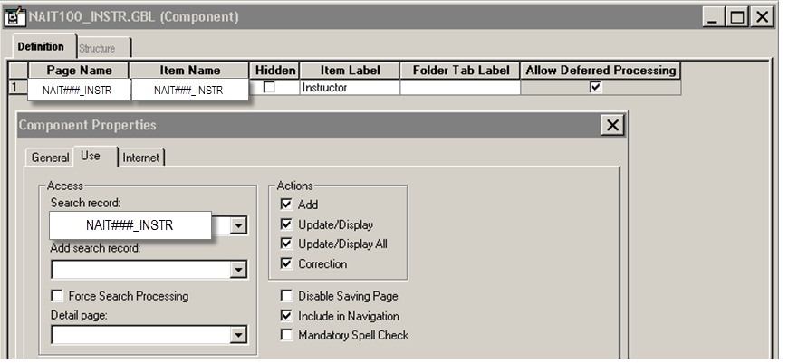

Search Record: NAIT###_INSTR

**7. Register Components**

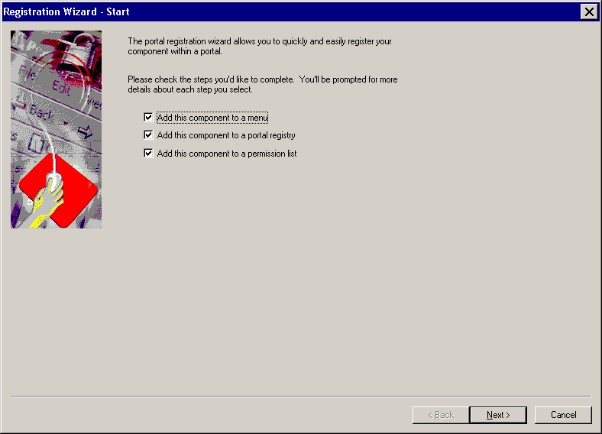

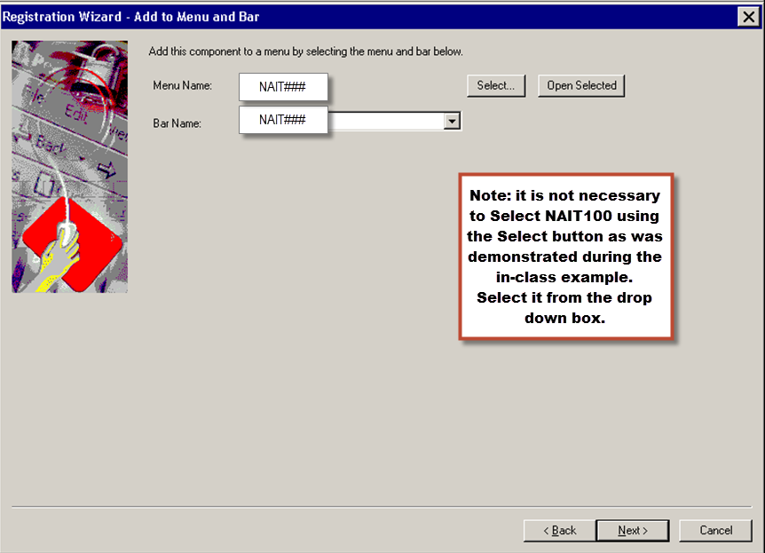

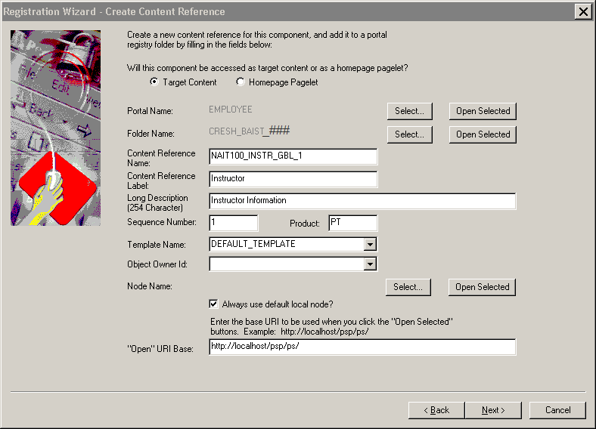

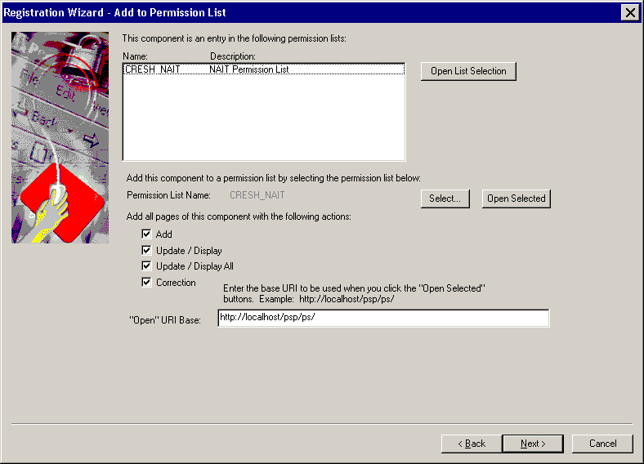

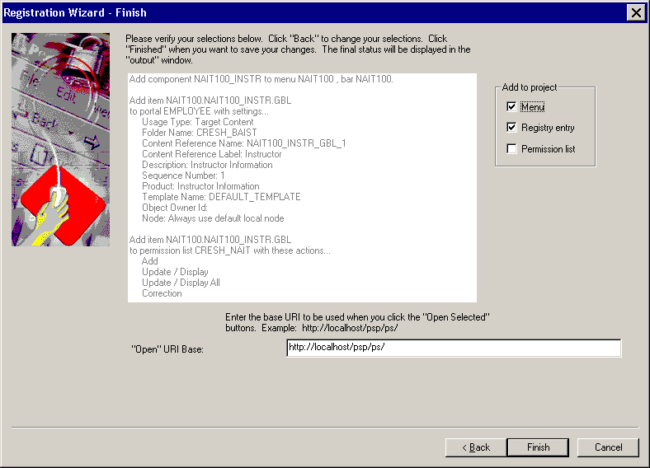

Don’t forget to save your Project

Menu

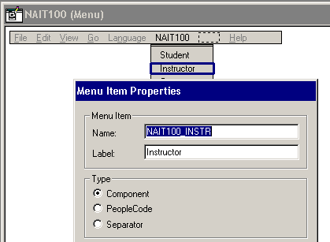

**8. Test the application**

Add 5 Instructors:

001 – Instructor Homer Simpson was hired on September 1, 2013 for a 5 year contract. The Business Unit is CAN01, and Training Facility is WA304.

002 – Instructor Linda Webber was hired on January 6, 2014. She got married on March 11, 2015 her last name changed to Lee. The Business Unit is CAN01, and Training Facility is WA304.

003 – Bobby Deol starts working on March 13, 2015, and will be doing curriculum development. The Business Unit is CAN01, and Training Facility is WA306.

004 – Anthony Gonzalez started working on March 1, 2016. The Business Unit is CAN01, and Training Facility is WA307.

005 – Kim Black started working on April 1, 2016 and was terminated on December 5, 2016. The Business Unit is CAN01, and Training Facility is WA309.